

UNIVERSIDAD DEL DISTRITO FEDERAL,

CAMPUS SANTA MARÍA

ESPECIALIDAD: SISTEMAS DE INFORMACIÓN

**ASIGNATURA: AUDITORÍA DE SISTEMAS COMPUTACIONALES**

**“PROYECTO FINAL: *JUEGO 21*”**

Nombre del Alumno: Padilla Torres Guadalupe Antonio

Docente a cargo: Miguel Ángel Herrera Martín del Campo

Ciudad de México 22 de Junio de 2019.

**Descripción**

El siguiente trabajo es un juego desarrollado en lenguaje Java con las herramientas de JavaSwing. Se trata de una serie de paneles, campos de texto y etiquetas que se van editando conforme el curso del programa. El juego es el famoso “21”. Sólo pueden participar dos jugadores en ésta ocasión, pero las reglas son llegar lo más próximo o igual al número 21 en la suma de las cartas tomadas. El jugador que lo logre gana, si lo logran los dos el juego queda en empate. El código consta de condicionantes, imágenes y números random. Los campos de texto muestran la cantidad de cartas tomadas por cada jugador y sus puntajes. Las etiquetas muestran el estado de cada jugador y del juego.

**Pantallas**

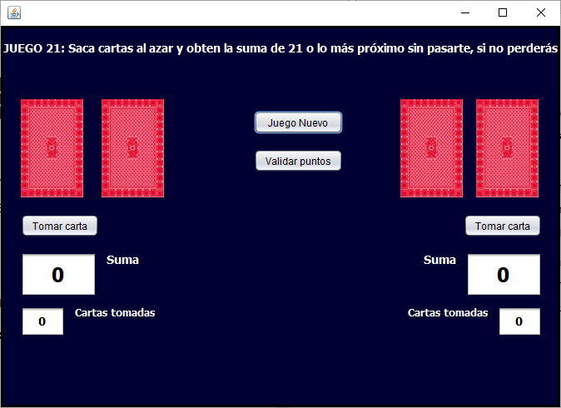

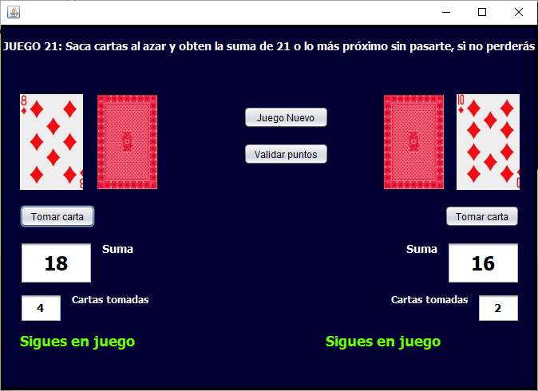

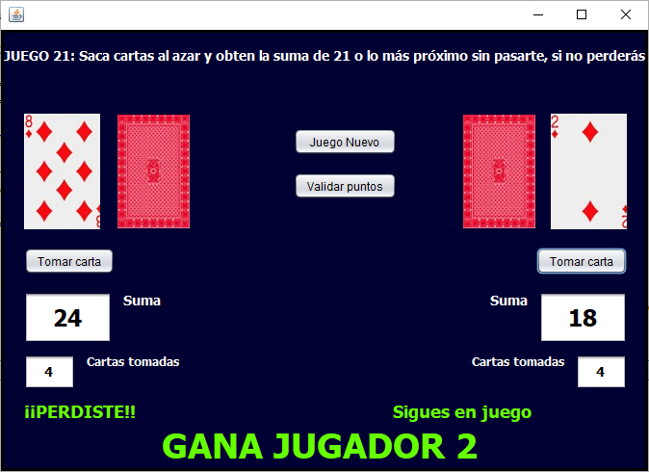

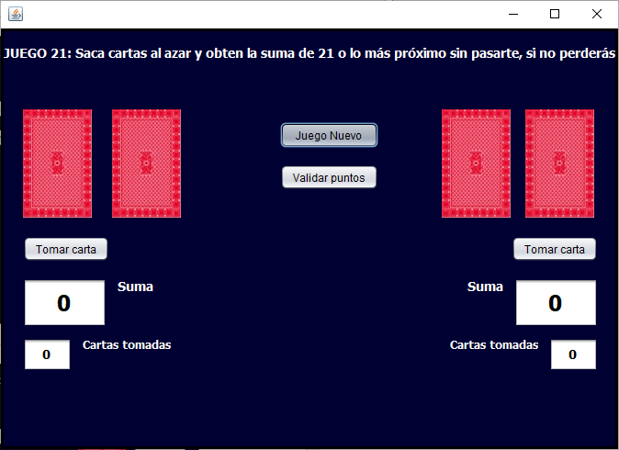

**Código**

import java.util.Random;

import javax.swing.ImageIcon;

public class VeintiUno extends javax.swing.JFrame {

public ImageIcon icoImagen;

int i1 = 0, j1, i2 = 0, j2;

int k1 = 0, k2 = 0;

public void Cartas1()

{

k1 += 1;

Tomadas1.setText("" +k1);

Random aleatorio = new Random();

int numero = aleatorio.nextInt(10) + 1;

if (numero == 1)

{

icoImagen = new ImageIcon("C:\\Users\\Alumnos\\Documents\\NetBeansProjects\\Cartas\\A.jpg");

jLabel3.setIcon(icoImagen);

j1 = 1;

i1 += j1;

Resultado1.setText("" +i1);

}

else if (numero == 2)

{

icoImagen = new ImageIcon("C:\\Users\\Alumnos\\Documents\\NetBeansProjects\\Cartas\\2.jpg");

jLabel3.setIcon(icoImagen);

j1 = 2;

i1 += j1;

Resultado1.setText("" +i1);

}

else if (numero == 3)

{

icoImagen = new ImageIcon("C:\\Users\\Alumnos\\Documents\\NetBeansProjects\\Cartas\\3.jpg");

jLabel3.setIcon(icoImagen);

j1 = 3;

i1 += j1;

Resultado1.setText("" +i1);

}

else if (numero == 4)

{

icoImagen = new ImageIcon("C:\\Users\\Alumnos\\Documents\\NetBeansProjects\\Cartas\\4.jpg");

jLabel3.setIcon(icoImagen);

j1 = 4;

i1 += j1;

Resultado1.setText("" +i1);

}

else if (numero == 5)

{

icoImagen = new ImageIcon("C:\\Users\\Alumnos\\Documents\\NetBeansProjects\\Cartas\\5.jpg");

jLabel3.setIcon(icoImagen);

j1 = 5;

i1 += j1;

Resultado1.setText("" +i1);

}

else if (numero == 6)

{

icoImagen = new ImageIcon("C:\\Users\\Alumnos\\Documents\\NetBeansProjects\\Cartas\\6.jpg");

jLabel3.setIcon(icoImagen);

j1 = 6;

i1 += j1;

Resultado1.setText("" +i1);

}

else if (numero == 7)

{

icoImagen = new ImageIcon("C:\\Users\\Alumnos\\Documents\\NetBeansProjects\\Cartas\\7.jpg");

jLabel3.setIcon(icoImagen);

j1 = 7;

i1 += j1;

Resultado1.setText("" +i1);

}

else if (numero == 8)

{

icoImagen = new ImageIcon("C:\\Users\\Alumnos\\Documents\\NetBeansProjects\\Cartas\\8.jpg");

jLabel3.setIcon(icoImagen);

j1 = 8;

i1 += j1;

Resultado1.setText("" +i1);

}

else if (numero == 9)

{

icoImagen = new ImageIcon("C:\\Users\\Alumnos\\Documents\\NetBeansProjects\\Cartas\\9.jpg");

jLabel3.setIcon(icoImagen);

j1 = 9;

i1 += j1;

Resultado1.setText("" +i1);

}

else

{

icoImagen = new ImageIcon("C:\\Users\\Alumnos\\Documents\\NetBeansProjects\\Cartas\\10.jpg");

jLabel3.setIcon(icoImagen);

j1 = 10;

i1 += j1;

Resultado1.setText("" +i1);

}

if (i1 < 21)

{

Estado1.setText("Sigues en juego");

}

else if (i1 > 21)

{

Estado1.setText("¡¡PERDISTE!!");

}

if (i1 < 21)

{

Estado1.setText("Sigues en juego");

}

else if (i1 > 21)

{

Estado1.setText("¡¡PERDISTE!!");

Estado3.setText("GANA JUGADOR 2");

}

}

public void Cartas2()

{

k2 += 1;

Tomadas2.setText("" +k2);

Random aleatorio = new Random();

int numero = aleatorio.nextInt(10) + 1;

if (numero == 1)

{

icoImagen = new ImageIcon("C:\\Users\\Alumnos\\Documents\\NetBeansProjects\\Cartas\\A.jpg");

jLabel2.setIcon(icoImagen);

j2 = 1;

i2 += j2;

Resultado2.setText("" +i2);

}

else if (numero == 2)

{

icoImagen = new ImageIcon("C:\\Users\\Alumnos\\Documents\\NetBeansProjects\\Cartas\\2.jpg");

jLabel2.setIcon(icoImagen);

j2 = 2;

i2 += j2;

Resultado2.setText("" +i2);

}

else if (numero == 3)

{

icoImagen = new ImageIcon("C:\\Users\\Alumnos\\Documents\\NetBeansProjects\\Cartas\\3.jpg");

jLabel2.setIcon(icoImagen);

j2 = 3;

i2 += j2;

Resultado2.setText("" +i2);

}

else if (numero == 4)

{

icoImagen = new ImageIcon("C:\\Users\\Alumnos\\Documents\\NetBeansProjects\\Cartas\\4.jpg");

jLabel2.setIcon(icoImagen);

j2 = 4;

i2 += j2;

Resultado2.setText("" +i2);

}

else if (numero == 5)

{

icoImagen = new ImageIcon("C:\\Users\\Alumnos\\Documents\\NetBeansProjects\\Cartas\\5.jpg");

jLabel2.setIcon(icoImagen);

j2 = 5;

i2 += j2;

Resultado2.setText("" +i2);

}

else if (numero == 6)

{

icoImagen = new ImageIcon("C:\\Users\\Alumnos\\Documents\\NetBeansProjects\\Cartas\\6.jpg");

jLabel2.setIcon(icoImagen);

j2 = 6;

i2 += j2;

Resultado2.setText("" +i2);

}

else if (numero == 7)

{

icoImagen = new ImageIcon("C:\\Users\\Alumnos\\Documents\\NetBeansProjects\\Cartas\\7.jpg");

jLabel2.setIcon(icoImagen);

j2 = 7;

i2 += j2;

Resultado2.setText("" +i2);

}

else if (numero == 8)

{

icoImagen = new ImageIcon("C:\\Users\\Alumnos\\Documents\\NetBeansProjects\\Cartas\\8.jpg");

jLabel2.setIcon(icoImagen);

j2 = 8;

i2 += j2;

Resultado2.setText("" +i2);

}

else if (numero == 9)

{

icoImagen = new ImageIcon("C:\\Users\\Alumnos\\Documents\\NetBeansProjects\\Cartas\\9.jpg");

jLabel2.setIcon(icoImagen);

j2 = 9;

i2 += j2;

Resultado2.setText("" +i2);

}

else

{

icoImagen = new ImageIcon("C:\\Users\\Alumnos\\Documents\\NetBeansProjects\\Cartas\\10.jpg");

jLabel2.setIcon(icoImagen);

j2 = 10;

i2 += j2;

Resultado2.setText("" +i2);

}

if (i2 < 21)

{

Estado2.setText("Sigues en juego");

}

else if (i2 > 21)

{

Estado2.setText("¡¡PERDISTE!!");

Estado3.setText("GANA JUGADOR 1");

}

}

public VeintiUno() {

initComponents();

setLocationRelativeTo(null);

}

@SuppressWarnings("unchecked")

// <editor-fold defaultstate="collapsed" desc="Generated Code">

private void initComponents() {

jPanel1 = new javax.swing.JPanel();

jLabel1 = new javax.swing.JLabel();

jLabel2 = new javax.swing.JLabel();

jLabel3 = new javax.swing.JLabel();

Tomar1 = new javax.swing.JButton();

Tomar2 = new javax.swing.JButton();

jLabel4 = new javax.swing.JLabel();

jLabel5 = new javax.swing.JLabel();

jButton1 = new javax.swing.JButton();

Resultado1 = new javax.swing.JTextField();

Resultado2 = new javax.swing.JTextField();

jLabel6 = new javax.swing.JLabel();

jLabel7 = new javax.swing.JLabel();

Tomadas1 = new javax.swing.JTextField();

Tomadas2 = new javax.swing.JTextField();

jLabel8 = new javax.swing.JLabel();

jLabel9 = new javax.swing.JLabel();

Estado1 = new javax.swing.JLabel();

Estado2 = new javax.swing.JLabel();

Estado3 = new javax.swing.JLabel();

jButton2 = new javax.swing.JButton();

setDefaultCloseOperation(javax.swing.WindowConstants.EXIT_ON_CLOSE);

jPanel1.setBackground(new java.awt.Color(0, 0, 51));

jPanel1.setBorder(javax.swing.BorderFactory.createLineBorder(new java.awt.Color(0, 0, 0), 3));

jLabel1.setFont(new java.awt.Font("Tahoma", 1, 14)); // NOI18N

jLabel1.setForeground(new java.awt.Color(255, 255, 255));

jLabel1.setHorizontalAlignment(javax.swing.SwingConstants.CENTER);

jLabel1.setText("JUEGO 21: Saca cartas al azar y obten la suma de 21 o lo más próximo sin pasarte, si no perderás");

jLabel2.setIcon(new javax.swing.ImageIcon("C:\\Users\\Alumnos\\Documents\\NetBeansProjects\\Cartas\\Volteada.jpg")); // NOI18N

jLabel3.setIcon(new javax.swing.ImageIcon("C:\\Users\\Alumnos\\Documents\\NetBeansProjects\\Cartas\\Volteada.jpg")); // NOI18N

Tomar1.setText("Tomar carta");

Tomar1.addActionListener(new java.awt.event.ActionListener() {

public void actionPerformed(java.awt.event.ActionEvent evt) {

Tomar1ActionPerformed(evt);

}

});

Tomar2.setText("Tomar carta");

Tomar2.addActionListener(new java.awt.event.ActionListener() {

public void actionPerformed(java.awt.event.ActionEvent evt) {

Tomar2ActionPerformed(evt);

}

});

jLabel4.setIcon(new javax.swing.ImageIcon(getClass().getResource("/Volteada.jpg"))); // NOI18N

jLabel5.setIcon(new javax.swing.ImageIcon(getClass().getResource("/Volteada.jpg"))); // NOI18N

jButton1.setText("Juego Nuevo");

jButton1.addActionListener(new java.awt.event.ActionListener() {

public void actionPerformed(java.awt.event.ActionEvent evt) {

jButton1ActionPerformed(evt);

}

});

Resultado1.setFont(new java.awt.Font("Tahoma", 1, 24)); // NOI18N

Resultado1.setHorizontalAlignment(javax.swing.JTextField.CENTER);

Resultado1.setText("0");

Resultado2.setEditable(false);

Resultado2.setFont(new java.awt.Font("Tahoma", 1, 24)); // NOI18N

Resultado2.setHorizontalAlignment(javax.swing.JTextField.CENTER);

Resultado2.setText("0");

jLabel6.setFont(new java.awt.Font("Tahoma", 1, 14)); // NOI18N

jLabel6.setForeground(new java.awt.Color(255, 255, 255));

jLabel6.setText("Suma");

jLabel7.setFont(new java.awt.Font("Tahoma", 1, 14)); // NOI18N

jLabel7.setForeground(new java.awt.Color(255, 255, 255));

jLabel7.setText("Suma");

Tomadas1.setEditable(false);

Tomadas1.setFont(new java.awt.Font("Tahoma", 1, 14)); // NOI18N

Tomadas1.setHorizontalAlignment(javax.swing.JTextField.CENTER);

Tomadas1.setText("0");

Tomadas2.setEditable(false);

Tomadas2.setFont(new java.awt.Font("Tahoma", 1, 14)); // NOI18N

Tomadas2.setHorizontalAlignment(javax.swing.JTextField.CENTER);

Tomadas2.setText("0");

jLabel8.setFont(new java.awt.Font("Tahoma", 1, 12)); // NOI18N

jLabel8.setForeground(new java.awt.Color(255, 255, 255));

jLabel8.setText("Cartas tomadas");

jLabel9.setFont(new java.awt.Font("Tahoma", 1, 12)); // NOI18N

jLabel9.setForeground(new java.awt.Color(255, 255, 255));

jLabel9.setText("Cartas tomadas");

Estado1.setFont(new java.awt.Font("Tahoma", 1, 18)); // NOI18N

Estado1.setForeground(new java.awt.Color(102, 255, 0));

Estado2.setFont(new java.awt.Font("Tahoma", 1, 18)); // NOI18N

Estado2.setForeground(new java.awt.Color(102, 255, 0));

Estado3.setFont(new java.awt.Font("Tahoma", 1, 36)); // NOI18N

Estado3.setForeground(new java.awt.Color(102, 255, 0));

jButton2.setText("Validar puntos");

jButton2.addActionListener(new java.awt.event.ActionListener() {

public void actionPerformed(java.awt.event.ActionEvent evt) {

jButton2ActionPerformed(evt);

}

});

javax.swing.GroupLayout jPanel1Layout = new javax.swing.GroupLayout(jPanel1);

jPanel1.setLayout(jPanel1Layout);

jPanel1Layout.setHorizontalGroup(

jPanel1Layout.createParallelGroup(javax.swing.GroupLayout.Alignment.LEADING)

.addComponent(jLabel1, javax.swing.GroupLayout.DEFAULT_SIZE, javax.swing.GroupLayout.DEFAULT_SIZE, Short.MAX_VALUE)

.addGroup(jPanel1Layout.createSequentialGroup()

.addGap(21, 21, 21)

.addGroup(jPanel1Layout.createParallelGroup(javax.swing.GroupLayout.Alignment.LEADING)

.addGroup(jPanel1Layout.createSequentialGroup()

.addComponent(Estado1, javax.swing.GroupLayout.PREFERRED_SIZE, 243, javax.swing.GroupLayout.PREFERRED_SIZE)

.addPreferredGap(javax.swing.LayoutStyle.ComponentPlacement.RELATED, javax.swing.GroupLayout.DEFAULT_SIZE, Short.MAX_VALUE)

.addComponent(Estado2, javax.swing.GroupLayout.PREFERRED_SIZE, 243, javax.swing.GroupLayout.PREFERRED_SIZE))

.addGroup(jPanel1Layout.createSequentialGroup()

.addComponent(Tomadas1, javax.swing.GroupLayout.PREFERRED_SIZE, 53, javax.swing.GroupLayout.PREFERRED_SIZE)

.addPreferredGap(javax.swing.LayoutStyle.ComponentPlacement.UNRELATED)

.addComponent(jLabel8)

.addPreferredGap(javax.swing.LayoutStyle.ComponentPlacement.RELATED, javax.swing.GroupLayout.DEFAULT_SIZE, Short.MAX_VALUE)

.addComponent(jLabel9)

.addPreferredGap(javax.swing.LayoutStyle.ComponentPlacement.UNRELATED)

.addComponent(Tomadas2, javax.swing.GroupLayout.PREFERRED_SIZE, 53, javax.swing.GroupLayout.PREFERRED_SIZE))

.addGroup(jPanel1Layout.createSequentialGroup()

.addComponent(Resultado1, javax.swing.GroupLayout.PREFERRED_SIZE, 91, javax.swing.GroupLayout.PREFERRED_SIZE)

.addPreferredGap(javax.swing.LayoutStyle.ComponentPlacement.UNRELATED)

.addComponent(jLabel6)

.addPreferredGap(javax.swing.LayoutStyle.ComponentPlacement.RELATED, javax.swing.GroupLayout.DEFAULT_SIZE, Short.MAX_VALUE)

.addComponent(jLabel7)

.addPreferredGap(javax.swing.LayoutStyle.ComponentPlacement.UNRELATED)

.addComponent(Resultado2, javax.swing.GroupLayout.PREFERRED_SIZE, 91, javax.swing.GroupLayout.PREFERRED_SIZE))

.addGroup(javax.swing.GroupLayout.Alignment.TRAILING, jPanel1Layout.createSequentialGroup()

.addComponent(Tomar1)

.addPreferredGap(javax.swing.LayoutStyle.ComponentPlacement.RELATED, javax.swing.GroupLayout.DEFAULT_SIZE, Short.MAX_VALUE)

.addComponent(Tomar2))

.addGroup(javax.swing.GroupLayout.Alignment.TRAILING, jPanel1Layout.createSequentialGroup()

.addComponent(jLabel3, javax.swing.GroupLayout.PREFERRED_SIZE, 79, javax.swing.GroupLayout.PREFERRED_SIZE)

.addGap(18, 18, 18)

.addComponent(jLabel4, javax.swing.GroupLayout.PREFERRED_SIZE, 79, javax.swing.GroupLayout.PREFERRED_SIZE)

.addGap(104, 104, 104)

.addGroup(jPanel1Layout.createParallelGroup(javax.swing.GroupLayout.Alignment.LEADING, false)

.addComponent(jButton2, javax.swing.GroupLayout.DEFAULT_SIZE, javax.swing.GroupLayout.DEFAULT_SIZE, Short.MAX_VALUE)

.addComponent(jButton1, javax.swing.GroupLayout.DEFAULT_SIZE, javax.swing.GroupLayout.DEFAULT_SIZE, Short.MAX_VALUE))

.addPreferredGap(javax.swing.LayoutStyle.ComponentPlacement.RELATED, javax.swing.GroupLayout.DEFAULT_SIZE, Short.MAX_VALUE)

.addComponent(jLabel5, javax.swing.GroupLayout.PREFERRED_SIZE, 79, javax.swing.GroupLayout.PREFERRED_SIZE)

.addPreferredGap(javax.swing.LayoutStyle.ComponentPlacement.UNRELATED)

.addComponent(jLabel2, javax.swing.GroupLayout.PREFERRED_SIZE, 79, javax.swing.GroupLayout.PREFERRED_SIZE)))

.addGap(19, 19, 19))

.addGroup(jPanel1Layout.createSequentialGroup()

.addGap(164, 164, 164)

.addComponent(Estado3, javax.swing.GroupLayout.PREFERRED_SIZE, 371, javax.swing.GroupLayout.PREFERRED_SIZE)

.addContainerGap(javax.swing.GroupLayout.DEFAULT_SIZE, Short.MAX_VALUE))

);

jPanel1Layout.setVerticalGroup(

jPanel1Layout.createParallelGroup(javax.swing.GroupLayout.Alignment.LEADING)

.addGroup(jPanel1Layout.createSequentialGroup()

.addGroup(jPanel1Layout.createParallelGroup(javax.swing.GroupLayout.Alignment.LEADING)

.addGroup(jPanel1Layout.createSequentialGroup()

.addComponent(jLabel1, javax.swing.GroupLayout.PREFERRED_SIZE, 46, javax.swing.GroupLayout.PREFERRED_SIZE)

.addGap(38, 38, 38)

.addGroup(jPanel1Layout.createParallelGroup(javax.swing.GroupLayout.Alignment.LEADING)

.addComponent(jLabel2, javax.swing.GroupLayout.PREFERRED_SIZE, 120, javax.swing.GroupLayout.PREFERRED_SIZE)

.addComponent(jLabel5, javax.swing.GroupLayout.PREFERRED_SIZE, 120, javax.swing.GroupLayout.PREFERRED_SIZE)

.addComponent(jLabel4, javax.swing.GroupLayout.PREFERRED_SIZE, 120, javax.swing.GroupLayout.PREFERRED_SIZE)

.addComponent(jLabel3, javax.swing.GroupLayout.PREFERRED_SIZE, 120, javax.swing.GroupLayout.PREFERRED_SIZE)))

.addGroup(jPanel1Layout.createSequentialGroup()

.addGap(99, 99, 99)

.addComponent(jButton1)

.addGap(18, 18, 18)

.addComponent(jButton2)))

.addGap(19, 19, 19)

.addGroup(jPanel1Layout.createParallelGroup(javax.swing.GroupLayout.Alignment.BASELINE)

.addComponent(Tomar1)

.addComponent(Tomar2))

.addGap(18, 18, 18)

.addGroup(jPanel1Layout.createParallelGroup(javax.swing.GroupLayout.Alignment.LEADING)

.addComponent(Resultado2, javax.swing.GroupLayout.PREFERRED_SIZE, 53, javax.swing.GroupLayout.PREFERRED_SIZE)

.addComponent(Resultado1, javax.swing.GroupLayout.PREFERRED_SIZE, 53, javax.swing.GroupLayout.PREFERRED_SIZE)

.addGroup(jPanel1Layout.createParallelGroup(javax.swing.GroupLayout.Alignment.BASELINE)

.addComponent(jLabel6)

.addComponent(jLabel7)))

.addPreferredGap(javax.swing.LayoutStyle.ComponentPlacement.UNRELATED)

.addGroup(jPanel1Layout.createParallelGroup(javax.swing.GroupLayout.Alignment.LEADING)

.addComponent(Tomadas1, javax.swing.GroupLayout.PREFERRED_SIZE, 36, javax.swing.GroupLayout.PREFERRED_SIZE)

.addComponent(Tomadas2, javax.swing.GroupLayout.PREFERRED_SIZE, 36, javax.swing.GroupLayout.PREFERRED_SIZE)

.addComponent(jLabel8)

.addComponent(jLabel9))

.addPreferredGap(javax.swing.LayoutStyle.ComponentPlacement.UNRELATED)

.addGroup(jPanel1Layout.createParallelGroup(javax.swing.GroupLayout.Alignment.LEADING)

.addComponent(Estado1, javax.swing.GroupLayout.PREFERRED_SIZE, 23, javax.swing.GroupLayout.PREFERRED_SIZE)

.addComponent(Estado2, javax.swing.GroupLayout.PREFERRED_SIZE, 23, javax.swing.GroupLayout.PREFERRED_SIZE))

.addPreferredGap(javax.swing.LayoutStyle.ComponentPlacement.RELATED, javax.swing.GroupLayout.DEFAULT_SIZE, Short.MAX_VALUE)

.addComponent(Estado3, javax.swing.GroupLayout.PREFERRED_SIZE, 35, javax.swing.GroupLayout.PREFERRED_SIZE)

.addContainerGap())

);

javax.swing.GroupLayout layout = new javax.swing.GroupLayout(getContentPane());

getContentPane().setLayout(layout);

layout.setHorizontalGroup(

layout.createParallelGroup(javax.swing.GroupLayout.Alignment.LEADING)

.addComponent(jPanel1, javax.swing.GroupLayout.DEFAULT_SIZE, javax.swing.GroupLayout.DEFAULT_SIZE, Short.MAX_VALUE)

);

layout.setVerticalGroup(

layout.createParallelGroup(javax.swing.GroupLayout.Alignment.LEADING)

.addComponent(jPanel1, javax.swing.GroupLayout.DEFAULT_SIZE, javax.swing.GroupLayout.DEFAULT_SIZE, Short.MAX_VALUE)

);

pack();

}// </editor-fold>

private void Tomar1ActionPerformed(java.awt.event.ActionEvent evt) {

Cartas1();

}

private void Tomar2ActionPerformed(java.awt.event.ActionEvent evt) {

Cartas2();

}

private void jButton1ActionPerformed(java.awt.event.ActionEvent evt) {

Resultado1.setText("0");

Resultado2.setText("0");

Tomadas1.setText("0");

Tomadas2.setText("0");

Estado1.setText("");

Estado2.setText("");

Estado3.setText("");

icoImagen = new ImageIcon("C:\\Users\\Alumnos\\Documents\\NetBeansProjects\\Cartas\\Volteada.jpg");

jLabel3.setIcon(icoImagen);

icoImagen = new ImageIcon("C:\\Users\\Alumnos\\Documents\\NetBeansProjects\\Cartas\\Volteada.jpg");

jLabel2.setIcon(icoImagen);

i1 = 0;

i2 = 0;

k1 = 0;

k2 = 0;

}

private void jButton2ActionPerformed(java.awt.event.ActionEvent evt) {

if (i1 == 21 && i2 == 21)

{

Estado3.setText("Â¡EMPATE!");

Estado1.setText("");

Estado2.setText("");

}

else if (i1 == 21 && i2 < 21)

{

Estado3.setText("¡GANA JUGADOR 1");

Estado1.setText("");

Estado2.setText("");

}

else if (i2 == 21 && i1 < 21)

{

Estado3.setText("¡GANA JUGADOR 2");

Estado1.setText("");

Estado2.setText("");

}

}

/**

* @param args the command line arguments

*/

public static void main(String args[]) {

/* Set the Nimbus look and feel */

//<editor-fold defaultstate="collapsed" desc=" Look and feel setting code (optional) ">

/* If Nimbus (introduced in Java SE 6) is not available, stay with the default look and feel.

* For details see http://download.oracle.com/javase/tutorial/uiswing/lookandfeel/plaf.html

*/

try {

for (javax.swing.UIManager.LookAndFeelInfo info : javax.swing.UIManager.getInstalledLookAndFeels()) {

if ("Nimbus".equals(info.getName())) {

javax.swing.UIManager.setLookAndFeel(info.getClassName());

break;

}

}

} catch (ClassNotFoundException ex) {

java.util.logging.Logger.getLogger(VeintiUno.class.getName()).log(java.util.logging.Level.SEVERE, null, ex);

} catch (InstantiationException ex) {

java.util.logging.Logger.getLogger(VeintiUno.class.getName()).log(java.util.logging.Level.SEVERE, null, ex);

} catch (IllegalAccessException ex) {

java.util.logging.Logger.getLogger(VeintiUno.class.getName()).log(java.util.logging.Level.SEVERE, null, ex);

} catch (javax.swing.UnsupportedLookAndFeelException ex) {

java.util.logging.Logger.getLogger(VeintiUno.class.getName()).log(java.util.logging.Level.SEVERE, null, ex);

}

//</editor-fold>

/* Create and display the form */

java.awt.EventQueue.invokeLater(new Runnable() {

public void run() {

new VeintiUno().setVisible(true);

}

});

}

// Variables declaration - do not modify

private javax.swing.JLabel Estado1;

private javax.swing.JLabel Estado2;

private javax.swing.JLabel Estado3;

private javax.swing.JTextField Resultado1;

private javax.swing.JTextField Resultado2;

private javax.swing.JTextField Tomadas1;

private javax.swing.JTextField Tomadas2;

private javax.swing.JButton Tomar1;

private javax.swing.JButton Tomar2;

private javax.swing.JButton jButton1;

private javax.swing.JButton jButton2;

private javax.swing.JLabel jLabel1;

private javax.swing.JLabel jLabel2;

private javax.swing.JLabel jLabel3;

private javax.swing.JLabel jLabel4;

private javax.swing.JLabel jLabel5;

private javax.swing.JLabel jLabel6;

private javax.swing.JLabel jLabel7;

private javax.swing.JLabel jLabel8;

private javax.swing.JLabel jLabel9;

private javax.swing.JPanel jPanel1;

// End of variables declaration

}